 | Autumn 1 | Autumn 2 | Spring 1 | Spring 2 | Summer 1 | Summer 2
Reception Class  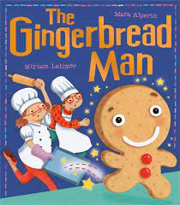  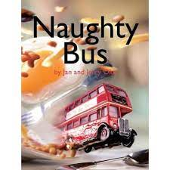  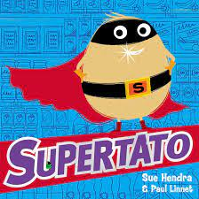 | The Gingerbread Man by Mara Alperin  Genre of writing:  Oral retelling, drawing images, writing labels.  Link Texts:  ‘Rosie’s walk’ by Pat Hutchins  ‘A great big cuddle’ by Michael Rosen  ‘Biscuit bear’ by Mini Grey  POETRY:  Creepy Crawly’ by anon  ‘Busy bugs’ by James Carter | I’m Going to Eat This Ant by Chris Naylor-Ballesteros  Genre of writing:  Creating lists  Link Texts:  ‘Flashlight’ by Lizi Boyd  ‘Guess who’s in the trees/ grass/ sand’ by Camilla Bedoyere | Naughty Bus by Jan and Jerry Oke  Genre of writing:  Recounts  Link Texts:  ‘On the road with Mavis and Marge’ by Niamh Sharkey  ‘You can’t take an elephant on the bus’ by Patricia Cleveland Peck  ‘The train ride’ by June Crebbin | The Journey Home by Emma Levey  Genre of writing:  Journey story  Link Texts:  ‘Hattie Peck’ by Emma Levey  ‘The way back home’ by Oliver Jeffers  POETRY:  ‘The farmyard’ by A.A. Attwood | Silly Doggy! by Adam Stowe  Genre of writing:  Retell/rewrite of a story  Link Texts:  ‘Hello Kitty’ by Adam Stower  ‘Hairy Maclary’ by Linley Dodd  POETRY:  ‘Eat your peas Louise’ by Peegen Snow  ‘Dinner time rhyme’ by June Crebbin | Supertato by Sue Hendra  Genre of writing:  Poster  Link Texts:  ‘Even superheroes have a bad day’ by Shelley Becker  ‘Super duck’ by Jez Alborough  ‘Gigantic Turnip’ by Aleksei Tolstoy
Year 1  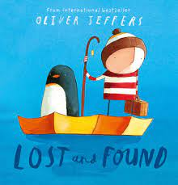  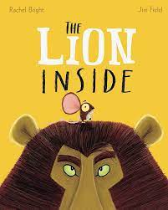  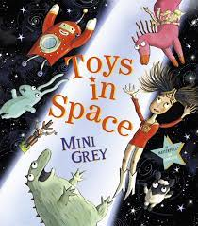 | Lost and Found by Oliver Jeffers  Genre of writing:  Adventure story  Link Texts:  ‘Be brave little penguin’ by Giles Andreae  ‘The Emperor’s egg’ by Martin Jenkins  ‘The penguin who wanted to find out’ by Jill Tomlinson  POETRY:  ‘There are no such things as monsters’ by Roger Stevens | Nibbles by Emma Yarlett  Genre of writing:  Diary entry  Link Texts:  ‘Goldilocks and the three bears’ by Emma Chichester Clark  ‘Little Red Riding Hood and Jack and the Beanstalk’ texts  ‘The Gruffalo’ by Julia Donaldson  ‘Where the wild things are’  by Maurice Sendak | The lion inside by Rachel Bright  Genre of writing:  Friendship story  Link Texts:  ‘How to be a lion’ by Ed Vere  ‘The tiger who came to tea’ by Judith Kerr  ‘Mog the forgetful cat’ by Judith Kerr  POETRY:  ‘At the zoo’ by W M Thackeray | The Curious Case of the Missing Mammoth by Ellie Hattie  Genre of writing:  Story with a new character  Link Texts:  ‘Lost in the toy museum’ by David Lucas  ‘Woolly Mammoth’ by Mick Manning  ‘How to wash a woolly mammoth’ by Michelle Robinson and Kate Hindley | Toys in Space by Mini Grey  Genre of writing:  Fantasy story  Link Texts:  Space Dog by Mini Grey  ‘It was a dark and stormy night’ by Janet and Allan Ahlberg  ‘One true bear’ by Ted Dewan  POETRY:  ‘Poetry fruit salad’ – various poets | Goldilocks and just the one bear by Leigh Hodgkinson  Genre of writing:  New version of story  Link Texts:  ‘Old bear stories’ by Jane Hissey  ‘Dogger’ by Shirley Hughes  ‘Scaredy bear’ by Steve Smallman
Year 2  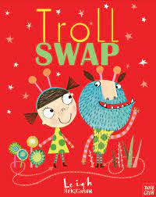  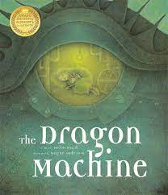 | ‘Troll Swap’ by Leigh Hodkinson  Genre of writing:  Story  Link text: ‘Trolls go home’ by Alan Macdonald  POETRY: ‘The owl and the pussycat’ by Edward Lear | ‘Where the poppies now grow.’  ‘The owl who was afraid of the dark’ by Jill Tomlinson.  Genre of writing:  Information fact sheet  Link text: ‘The owl who was afraid of the dark’ chapter book. | ‘Dragon machine’ by Helen Ward.  Genre of writing:  Story based on a moral dilemma  Link text: ‘The Dragonsitter series’ by Josh Lacey.  POETRY: ‘Night sounds’ by Bertie Doherty | ‘Major Glad, Major Dizzy’ by Jan Oke.  Genre of writing:  Recount  Link text: ‘Naughty Amelia Jane’ by Enid Blyton | ‘The last wolf’ by Mini Grey.  Genre of writing: Persuasive letter  Link Text: ‘Fantastic Mr Fox’ by Roald Dahl  POETRY:  ‘Fox’ by Kathy Henderson | ‘Grandad’s secret giant’ by David Litchfield.  Genre of writing: Moral story  Link text: ‘The BFG’ by Roald Dahl.
Year 3  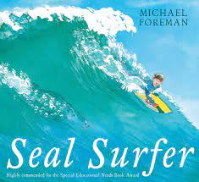  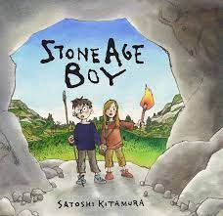 | ‘Seal surfer’ by Michael Foreman.  Genre of writing:  Letter  Link Text: ‘Dancing bear’ by Michael Morpurgo.  POETRY:  ‘Dance with me Autumn’ – various poets | ‘Winter’s child’ by Angela McAllister  Genre of writing: Fantasy story  Link Text: Ice Palace by Robert Swindells | ‘Stone age boy’ by Satoshi Kitamura.  Genre of writing: Story in 1st person  Link Text: ‘The Iron man’ by Ted Hughes.  POETRY:  ‘The magnificent bull from the Dinka tribe.’ | ‘Big blue whale’ by Nicola Davies.  Genre of writing: Persuasion  Link Text: ‘This morning I met a whale’ by Michael Morpurgo. | ‘Journey’ by Aaron Becker.  Genre of writing: Adventure story  Link Text: Tilly Mint tales by Berlie Doherty.  POETRY:  ‘Apes to zebras.’ | ‘Zeraffa Giraffa’ by Dianne Hoffmeyr  Genre of writing: Persuasive guide  Link Text: White giraffe by Lauren St John.
Year 4  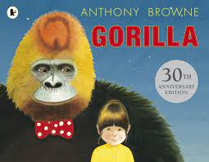  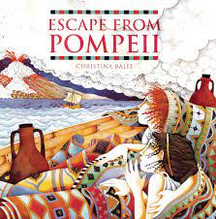 | Gorilla by Anthony  Browne  Genre of writing:  Fiction: fantasy story  Link text: ‘Ape’ by Martin Jenkins  ‘The one and only Ivan’ by Katherine Applegate  POETRY:  ‘The lost property office’ by Roger McGough | Leon and the place between by Graham Baker-Smith  Genre of writing:  Recount /diary  Link text: ‘The nowhere emporium’ by Ross Mackenzie | Escape From Pompeii by Christina Balit  Genre of writing:  Fiction: historical narrative  Link text: ‘Pompei – A Roman girl’s diary’ by Sue Reid  POETRY:  ‘Windrush child’ by John Agard | When the Giant stirred by Celia Godkin  Genre of writing:  Fiction: adventure story  Link text: ‘Journey to the centre of the earth’ by Jules Vernes | Where the Forest Meets the Sea by Jeannie Baker 100 facts – Rainforests by Miles Kelly  Genre of writing:  Non-chronological report  Link Text: ‘Cave challenge’ by Bear Grylls  POETRY:  ‘I am the seed that grew the tree’ by Fiona Waters. | Blue John by Berlie Doherty  Clockwork by Phillip Pullman or alternative Berlie Doherty novel  Genre of writing:Explanation: letter in role  Link text: ‘The boy who biked the world’ by Alastair Humphreys
Year 5  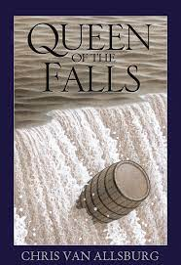  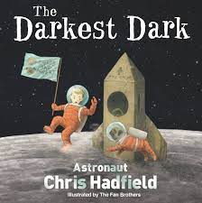 | Queen of the Falls by Chris Van Allsberg  Genre of writing:  Recount: Series of Diaries  Link Texts: Goodnight Stories for Rebel Girls by Elena Favilli  POETRY:  ‘The moon’ by various poets | The Lost Happy Endings by Carol Ann Duffy  Genre of writing:  Fiction: Traditional Tale  Link texts:  Hansel and Gretel by Neil Gaiman | Arthur and the Golden Rope by Joe Todd-Stanton  Genre of writing:  Fiction: myth  Create heroes, villains and monsters  Link texts:  Myths of the Norsemen by Roger Lancelyn Green  Poetry:  ‘Finding magic’ by Eric Finey | The Darkest Dark by astronaut Chris Hadfield  Genre of writing:  Recount: Biography  Link texts:  Cosmic by Frank Cottrell Boyce or The Boy Who Climbed to the Moon by David Almond | The Paperbag Prince by Colin Thompson  Genre of writing:  Persuasion/Information: Hybrid leaflet  Link texts:  The Lost Wild by Piers Torday  POETRY:  ‘Animals of Africa’ by various poets. | ‘Radiant child’ by Jean-Michel Basquiat  Genre of writing: Adventure story  Link texts: ‘The child’s elephant’ by Rachel Campbell-Johnston
Year 6  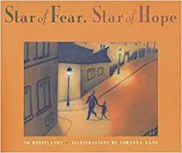  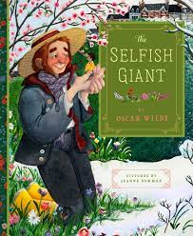 | Star of Hope, Star of Fear by Jo Hoestlandt  Genre of writing: Flashback story  Link text:  An Eagle in the snow by Michael Morpurgo  POETRY  ‘A tiger in the zoo’ by Leslie Norris. | Dulce and Decorum est – by Wilfred Owen  Can we save the tiger? by Martin Jenkins  Genre of writing: Report booklet  Link text:  Jungle Book by Rudyard Kipling | Selfish Giant by Oscar Wilde  Genre of writing: 1st person narrative  Link text:  Gulliver’s Travels retold by Martin Jenkins, illustrated by Chris Riddell  POETRY:  ‘The sea’ by James Reeves | Jemmy Button by Alix Barzelay  Genre of writing: Journalistic report  Link text:  The Island by Jason Chin  The Explorer by Katherine Rundell | Manfish by Jennifer Berne  Genre of writing: Biography  Link text:  Dolphin Song by Lauren St John  POETRY:  ‘Sonnet written at the close of Spring’ by Charlotte Smith. | Transition Unit  Sky Chasers by Emma Carroll  Genre of writing: Adventure story  Link text: Around the world in 80 days by Jules Vernes

