

**Year 5 History**

**Knowledge Organiser**

**Trojan Horse**

**Subject Specific Skills**

* Describe and explain main events
* Evaluate and critique
* Reach a conclusion and make a judgement
* Review and evaluate

**Prior Learning**

* 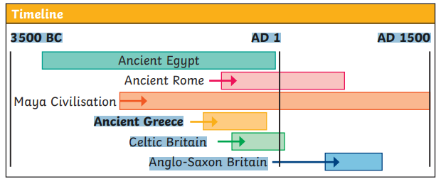

**Key Knowledge**

* The main events in the siege of the city of Troy during the Trojan War in Ancient Greece
* The visual, written and archaeological evidence which presently exists regarding the Trojan Horse, and begin to formulate conclusions
* Is the story of the Trojan War (in my opinion) fact, legend or classical myth
* Compare to the existence of the lost kingdom of Atlantis and reach a judgement as to its reliability and trustworthiness

**Key Individual** 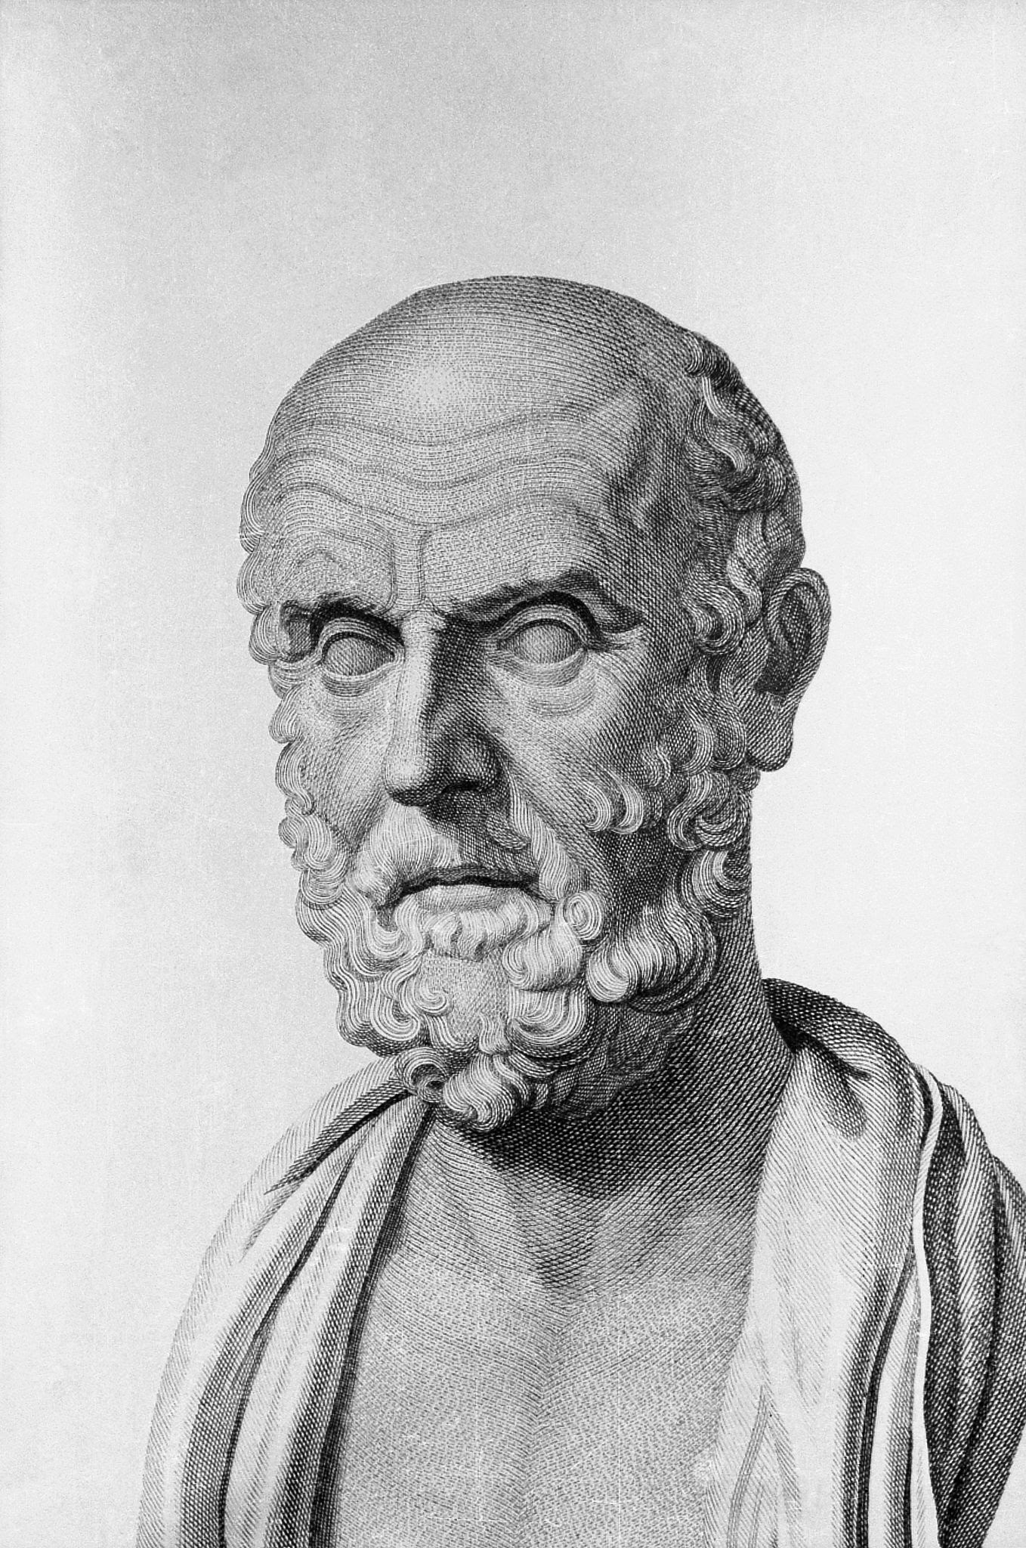

Hippocrates was a famous Greek doctor. He was one of the first people to notice that medicine should be a different part of science to philosophy. Additionally, he was one of the first doctors to identify lung cancer and heart disease. Doctors today have to pledge to follow the Hippocratic Oath named after him.

**Key Vocabulary**

The Trojan Horse; Ancient Greece; historians; authentic; truthful; accurate; factual; myth; traditional; celebrating; fantastic; exploits; hero; judgement; evaluate; Europe; Greece; kingdoms; government; city; Troy; Sparta; Mycenae; kidnapped; Paris of Troy; Queen Helen of Sparta; King Menelaus of Sparta; King Agamemnon of Mycenae; Aegean Sea; Odysseus; evidence; archaeology

**Key Knowledge**

The Trojan War is a very famous ancient Greek myth.

Many people believe that it is a myth but that there is some historical truth behind it. The Trojan War (which is believed to have lasted for ten years) was between the Greek and the Trojan Armies.

In the story, the Greeks pretended to surrender, leaving a gift of a giant horse for the Trojans. The gift was brought inside the city walls. In the night, Greek soldiers hiding inside the horse let the Greek army inside Troy’s walls and the city was destroyed.

Many poems were written about the Trojan War during the ancient Greek period. The most famous poems were written by a poet called Homer.