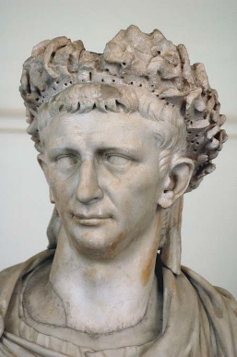

**Subject Specific Skills**

* **Identify and describe** the modern-day countries of

Europe and North Africa which formed part of the Roman Empire prior to invasion of Britain by Emperor Claudius;

* **Understand through explanation** the motives for Emperor Claudius to invade and occupy Britain in AD 43
* **Interpret** primary sources of historical evidence to describe the physical appearance of Boudica and make a judgment about the causes and effects of her harsh treatment by the Romans;
* **Compare and contrast** the armies of Boudica and the British Roman governor Paulinus and predict the likely outcome of their battle and justify their decision;
* **Identify and describe** the key features of the layout of typical Roman towns in Britain and **explain** why historians know so much about how they were designed and built
* **Understand through explanation** the difference

between historical evidence and legends and folklore;

**Prior Learning**

* **Identify and describe** in simple terms what the Roman Empire was and recognise some of the ways in which the lives of the rich and poor were different in the city of Pompeii;
* **Describe** the differences between primary and secondary historical evidence about what happened in Pompeii;
* **Identify, describe and suggest reasons** for the use of a range of smaller artefacts excavated by archaeologists at Pompeii;
* **Describe** one piece of personal secondary historical evidence and **explain** some of the ways in which it tells us about the lives of people at some point in the past.

**Year 4 History**

**Knowledge Organiser**

**Romans in Britain**

**Key Knowledge**

How the arrival of the Romans changed Britain

Why Emperor Claudius invaded – why did he come here?

Why the Romans almost lost control of Britain - Boudica

Roman archaeological finds – what do they tell us?

Hadrians wall – who built it? Why was it needed?

How do we know about the towns in Britain?

What did they leave behind?

Why did the Romans organise gladiatorial games?

**Key Individual**

Emperor Claudius – invaded Britain in 43AD

**Key Vocabulary**

Rome, Romans, Empire, Emperor, invasion, gladiators, slavery, battle, civilisation, Celts, Druid, legionnaires, tunic, toga, warrior, ambush, amphitheatre, basilica, guard house, mural, mosaics, Colosseum, testimonial, rebel, village