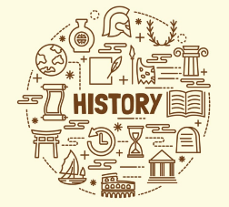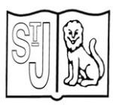

**Year 3**

**Early civilisations – what did the Ancient Egyptians achieve?**

**Subject Specific Skills**

* To establish what society was like in Britain during the Ancient Egyptian civilisation._
* Understand historical concepts such as similarity, difference and significance.
* Begin to understand the achievements of ancient civilisations.

**Prior Learning**

* Year 3 – how did the lives of ancient Britons change from the Stone Age through the Bronze Age to the Iron Age?_

**Key Knowledge**

_

**Key Individual**

_

**Key Vocabulary**

_ civilisation; timeline; society; Upper and Lower Egypt; River Nile; Pharaoh; diet

**Key Knowledge**

_ civilisation is an advanced stage of human development.

- the difference between what was happening in Britain and in Ancient Egypt…Circa 3000 BCE Ancient Egypt was a civilised society. Britain was in the New Stone Age. People were just beginning to farm, stone circles would be under construction, people would be hunting for food, there would be lakeside settlements and lots of woodland.