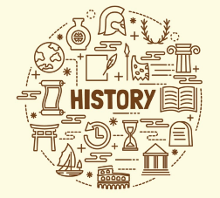

**Key Knowledge**

- Around 3500–4000 bc (between 5,500 and 6,000 years ago) and after nearly one million years, the Stone Age began to come to an end in Britain.

- For the first time in Britain people learned to make metal and the world changed for ever.

- During the Bronze Age most people were cremated and only very important individuals were given elaborate burials

- The Amesbury Archer indicates three very significant ways in which life in Britain advanced during the Bronze Age. 1. People began travelling and trading internationally. 2. a clear structure of social class began to take shape. 3. A belief in an afterlife

- In Bronze Age Britain people constructed hundreds of monuments all over the country that remain until this day.

**Year 3**

**How do the standing stones and other artefacts help us understand the lives of people in the Bronze & Iron Ages?**

**Subject Specific Skills**

* **Identify** and **describe** the likely use of a range of Bronze Age artefacts and **explain** why these items demonstrate progress in the way that people lived in Britain compared with the Stone Age;
* **Describe** the main features of an Iron Age hill fort and **identify** and **suggest reasons** for the purpose of artefacts found within them;
* _

**Prior Learning**

* Year 2 – How do we know so much about where Sappho used to live?
* Year 3 – How did the lives of ancient Britons change so much during the Stone Age?

**Key Knowledge**

- Archaeological artefacts are objects made by a human or groups of humans in the past.

- Hill forts that remain today can be recognised by 1. mounds of earth on the top of hills, 2. steep walls of earth (ramparts) around the top of the hill and 3. a large flat area at the very top of the hill inside the ramparts.

- The smelting of iron made it possible to make tools, weapons and armour far superior in strength than bronze.

- Life wasn’t always very peaceful in the Iron Age compared to the way it was in the Stone and Bronze Ages.

- Better tools for farming meant that people could eat healthier and lived longer. Also people were travelling into Britain. This meant that the population grew very quickly. Different tribes would attack each other for food and land.

**Key Individual**

_ 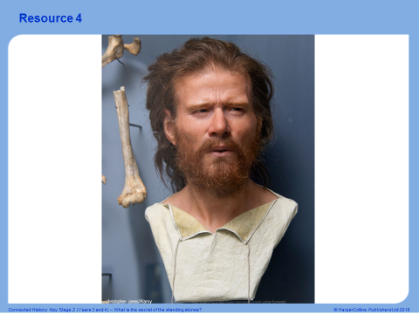

The Amesbury Archer

**Key Vocabulary**

Copper; tin; smelting; bronze; manufacture; discovery; artefacts; advancement; progress; social status; functional; skeleton; wealthy; powerful; hunter; warrior; community; status; trade; hill fort; area; mound; archaeologist; evidence; population; culture; social customs; religious beliefs; siege; barter; swap; exchange; goods; services;