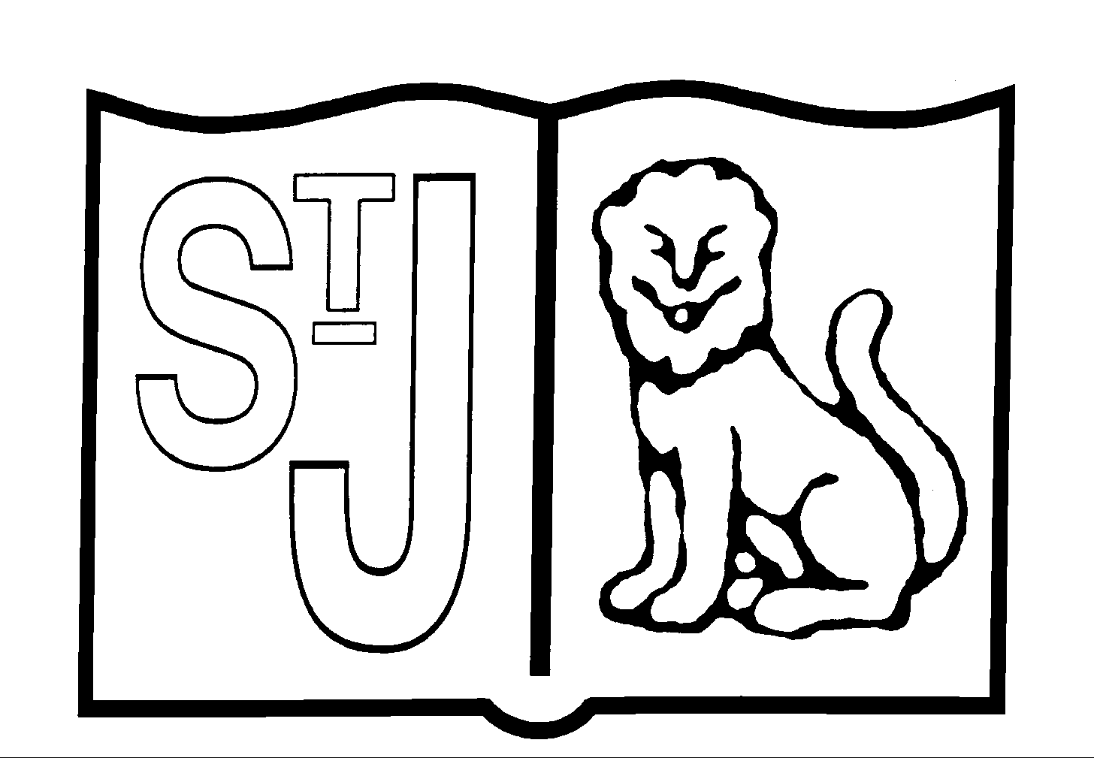
St Jerome’s Catholic Primary School
History Policy
Intent
Our vision for history is that we provide every child with high quality history experiences which engage and inspire them. We provide opportunities for all children to explore the past and look at historical events from close and far. We aim for every child to leave St Jerome’s Catholic Primary School with a knowledge of key historical events, investigation skills, knowledge and an understanding and an interest in history which they can carry with them for the rest of their lives. The aim of history is to develop the children’s awareness of the past and its effect on the present and future.

History is about real people who lived, and real events which happened in the past. History is concerned with sequence, time and chronology and is the study of evidence about the past; it gives us a sense of identity, set within our social, political, cultural and economic relationships. History fires the children’s curiosity about the past in Britain and the wider world and plays an essential part in preparing us for living and working in the contemporary world.

Pupils consider how the past influences the present, what past societies were like, how these societies organised their politics, and what beliefs and cultures influenced people’s actions. As they do this, children develop a chronological framework for their knowledge of significant events and people. They see the diversity of human experience, and understand more about themselves as individuals and members of society. What they learn can influence their decisions about personal choices, attitudes and values. In history, children find evidence, weigh it up and reach their own conclusions. To do this they need to be able to research, sift through evidence, and argue for their point of view – skills that are prized in adult life.

Implementation
History is taught throughout the school using the Connected History scheme as a teaching resource. Each class will study 3 history topics a year. These will include lessons in class, field work, trips and research activities.

Impact
- Fire pupils’ curiosity about the past in Britain and the wider world.
- Encourage thinking about how the past influences the present.
- Help students develop a chronological framework for their knowledge of significant events and people.
- Foster a sense of identity and an increased understanding of pupils’ own position in their local community and the world.
- Develop a range of skills and abilities – particularly those related to finding out about the past, explaining and communicating what happened and what people then and now think about what happened.
- To instil in the children a curiosity and understanding of events, places and people in a variety of times and environments.
- To develop an interest in the past and an appreciation of human achievements and aspirations
- To understand the values of our society
- To learn about the major issues and events in the history of our own country and of the world and how these events may have influenced one another
- To develop a knowledge of chronology within which the children can organise their understanding of the past
- To understand how the past was different from the present and that people of other times and places may have had different values and attitudes from ours
- To understand the nature of evidence by emphasising the process of enquiry and by developing the range of skills required to interpret primary and secondary source materials
- To distinguish between historical facts and the interpretation of those facts
- To understand that events have a multiplicity of causes and that historical explanation is provisional, debatable and sometimes controversial

Teaching and Learning
At St. Jerome’s history is taught within an integrated/topic approach which seeks to maximise cross-curricular links. Wherever possible we use first hand experiences and a variety of teaching approaches are used
- Individual, paired and group investigations into significant issues about the past.
- Investigating artefacts and sources of evidence such as people, photographs, written materials, portraits, ICT based materials, TV/video extracts.
- Fieldwork, including the local environment and visits to museums and sites of historical interest.
- Teacher presentations, role play, drama and story telling.
- Question and answer sessions, discussions and debates.
- Pupil presentations of their knowledge and understanding in a variety of ways such as through drama, art, models, various writing styles/genre, collage, timelines, sketches, maps.
- They have access to, and are able to handle artefacts
- They go on visits to museums and places of interest
- They have access to secondary sources such as books and photographs
- Visitors talk about personal experiences of the past
- They listen to and interact with stories from the past
- They undertake fieldwork by interviewing family and older friends about changes in their own and other people’s lives
- They use drama and dance to act out historical events
- They are shown, or use independently, resources from the internet and videos
- They are able to use non-fiction books for research
- They are provided with opportunities to work independently or collaboratively, to ask as well as answer historical questions.
The above approaches are designed to develop the 5 main historical skills of:
- chronology,
- understanding events, people and changes in the past,
- interpretation,
- enquiry,
- communication.

Subject specific events
- Women’s history week- whole school March
- Black history week- whole school October
- Remembrance

Resources
- Connected History scheme is used throughout school for year 1-6
- Range of books are available in the library
- Local history talk with local historian
- Where the poppies now grow
- Internet sites linked to Formby footprints
- Then and now local history book
- Local history walk with Eco-Centre

Assessment
Teachers regularly assess the children in class when asking questions, looking at work and discussions with pupils. Quizzes can be used at the end of topics to review children’s knowledge and progress. On completion of a piece of work, the teacher will assess the work and give oral feedback. Older and more able pupils are encouraged to make judgements about how they can improve their own work.
The History Progress Map will enable teachers to assess whether children are working below, above or at the expected level at the end of each year. Interim judgements will be made after each unit of work (half termly) and recorded on Balance.

Equal opportunities
Activities should be carefully planned by the class teacher and be differentiated where appropriate for children with SEN and equally the more able and Gifted and Talented children. All resources/materials have been reviewed with equal opportunities in mind, e.g. race, gender, ethnicity. Learning experiences in music will be available to every child, regardless of race, gender, class or ability. Pupils will be encouraged to value social and cultural diversity. They will listen to, and participate in, a variety of experiences in a positive and constructive role.

Inclusion
We recognise that in all classes, children have a wide range of history skills, and so we seek to provide suitable learning opportunities for all children by matching the challenge of the task to the ability of the child. We achieve this in a variety of ways:
- setting tasks which are open-ended and can have a variety of responses;
- setting tasks of increasing difficulty;
- grouping children by ability and setting different tasks for each group;
- grouping children in mixed ability groups;
- providing resources of different complexity, depending on the ability of the child;
- using additional adults (TAs) to support the work of individuals or groups of children.

Role of the Subject Leader
The coordination and planning of the history curriculum are overseen by the subject leader, who also:

- keeps colleagues and school governors informed about developments in history and provides a strategic lead and direction for the subject;
- keeps own CPD up-to-date and attends any relevant training;
- discusses progress with the Head Teacher and evaluates strengths and weaknesses in history;
- meets with children across the school to review the history teaching that is taking place;

Updated: June 2022
Agreed by Governors:_______________ Next Review: January 2024

