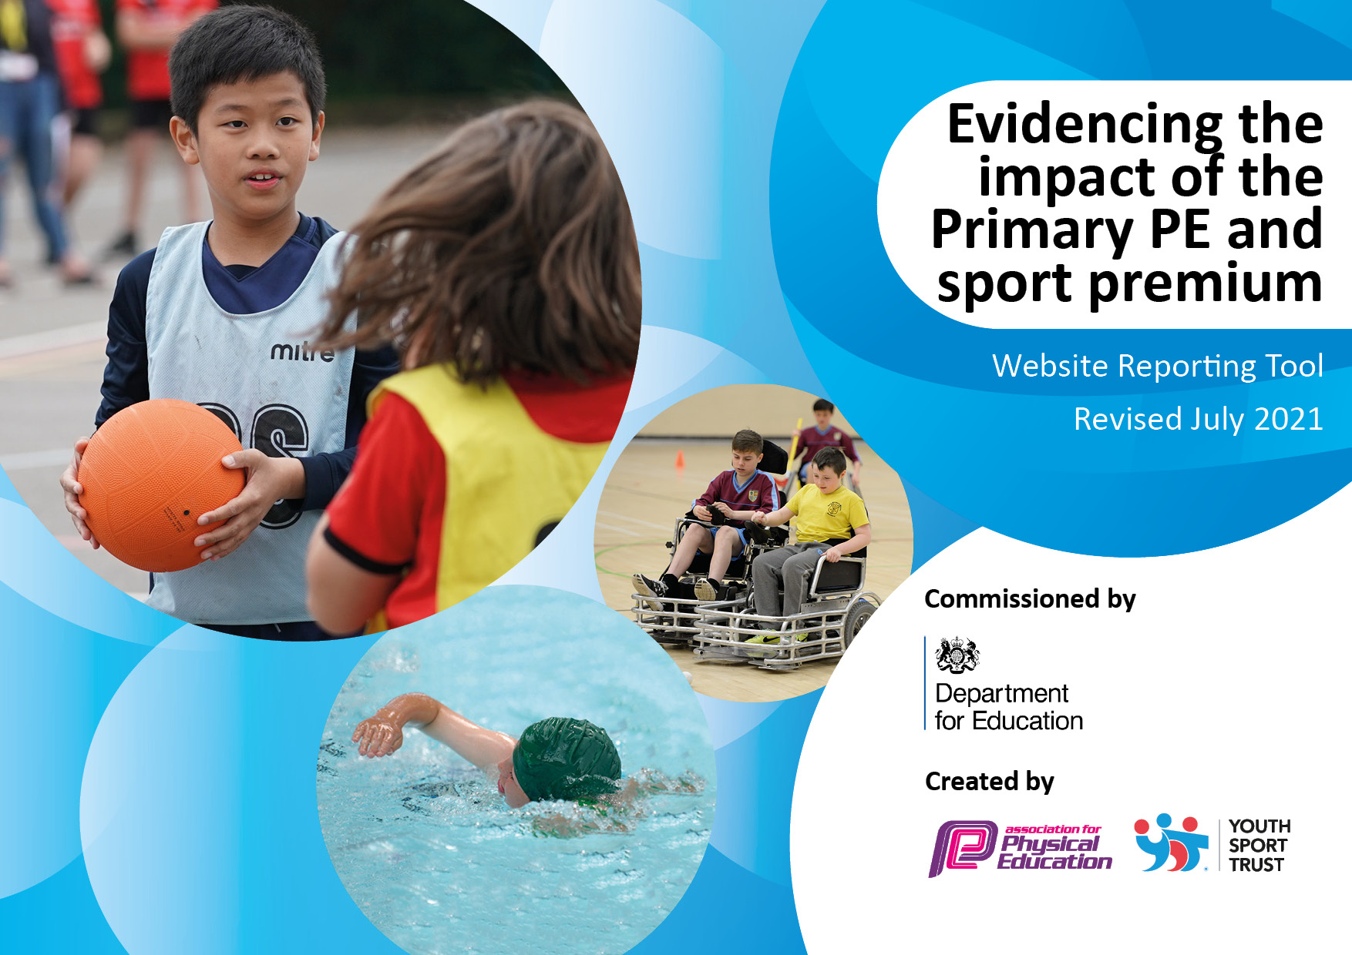

St Jerome’s Catholic Primary School

September 2025

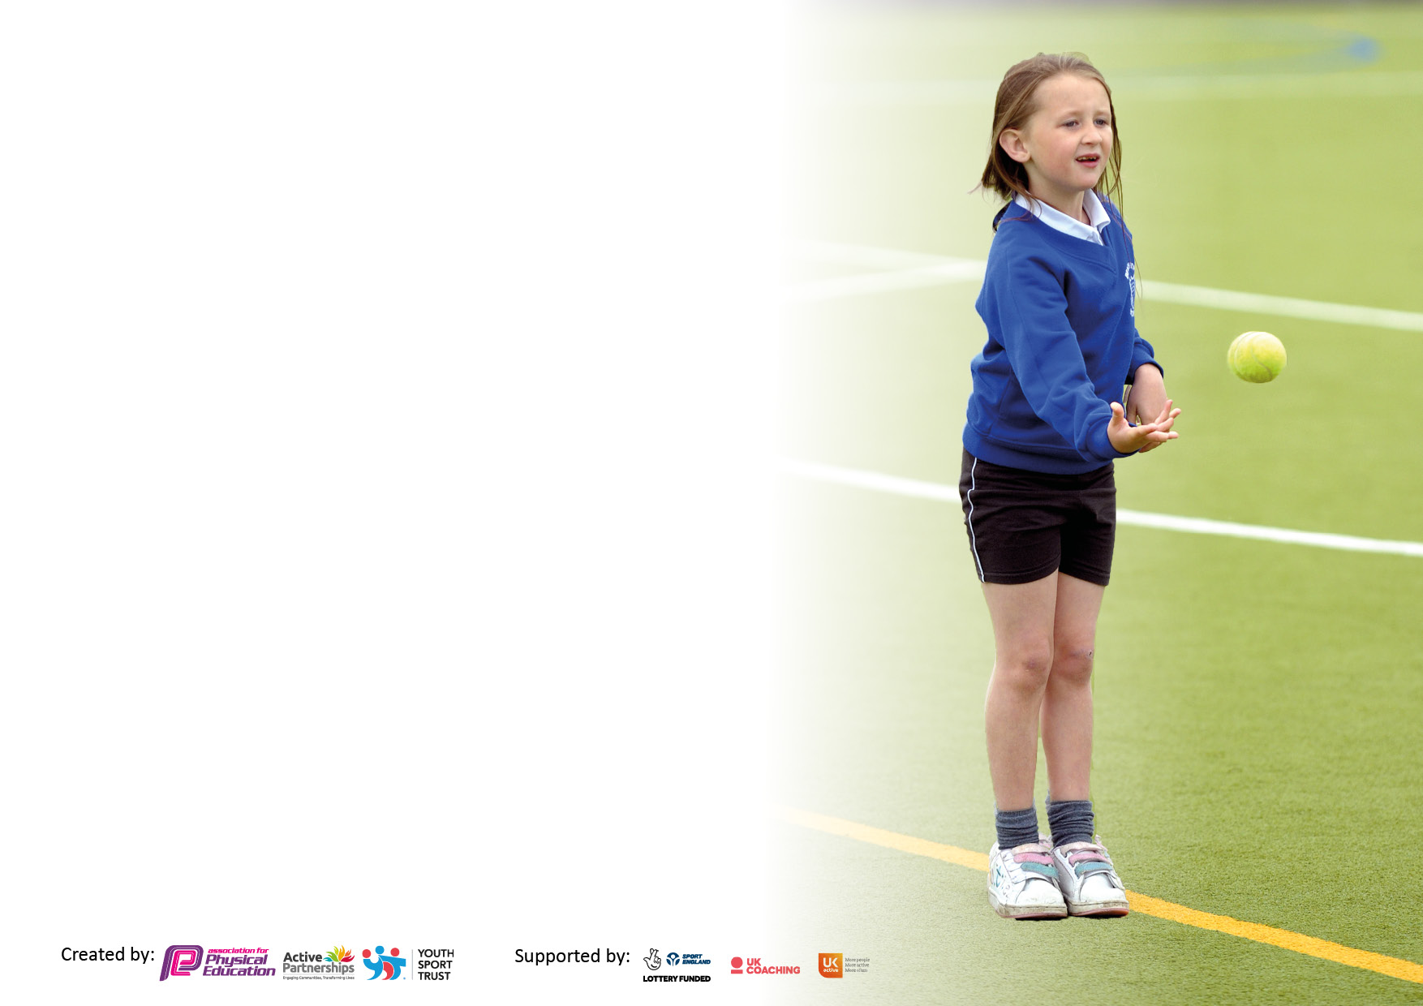

It is important that your grant is used effectively and based on school need. The Education Inspection Framework makes clear there will be a focus on **‘whether leaders and those responsible for governors all understand their respective roles and perform these in a way that enhances the effectiveness of the school’**.

Under the Quality of Education Ofsted inspectors consider:

**Intent** - Curriculum design, coverage and appropriateness

**Implementation** - Curriculum delivery, Teaching (pedagogy) and Assessment

**Impact** - Attainment and progress

To assist schools with common transferable language this template has been developed to utilise the same three headings which should make your plans easily transferable between working documents.

Schools must use the funding to make **additional and sustainable** improvements to the quality of Physical Education, School Sport and Physical Activity (PESSPA) they offer. This means that you should use the Primary PE and sport premium to:

* Develop or add to the PESSPA activities that your school already offer
* Build capacity and capability within the school to ensure that improvements made now will benefit pupils joining the school in future years
* The Primary PE and sport premium should not be used to fund capital spend projects; the school’s budget should fund these.

Pleasevisitgov.ukfortherevisedDfEguidanceincludingthe5keyindicatorsacrosswhichschoolsshoulddemonstrate animprovement.Thisdocumentwillhelpyoutoreviewyourprovisionandtoreportyourspend.DfEencouragesschools to use this template as an effective way of meeting the reporting requirements of the Primary PE and sport premium.

We recommend you start by reflecting on the impact of current provision and reviewing the previous spend.

Created by: Supported by:

**Details with regard to funding**

Please complete the table below.

|  |  |
| --- | --- |
| Total amount allocated for 2024/25 | £17720.00 |
| Total amount of funding for 2025/26. To be spent and reported on by 31st July 2026 | £17730.00 |

**Swimming Data**

Please report on your Swimming Data below.

|  |  |
| --- | --- |
| Meeting national curriculum requirements for swimming and water safety.  N.B. Complete this section to your best ability. For example you might have practised safe self-rescue techniques on dry land which you can then transfer to the pool when school swimming restarts.  **Due to exceptional circumstances priority should be given to ensuring that pupils can perform safe self rescue even if they do not fully meet the first two requirements of the NC programme of study** |  |
| What percentage of your current Year 6 cohort swim competently, confidently and proficiently over a distance of at least 25 metres? | 82% |
| What percentage of your current Year 6 cohort use a range of strokes effectively [for example, front crawl, backstroke and breaststroke]? | 10m front and back only – 82%  25m front and back only –82%  25m front back and breaststroke –63% |
| **What percentage of your current Year 6 cohort perform safe self-rescue in different water-based situations?** | 82% |
| Schools can choose to use the Primary PE and sport premium to provide additional provision for swimming but this must be for activity **over and above** the national curriculum requirements. Have you used it in this way? | No |

**Action Plan and Budget Tracking**

Capture your intended annual spend against the 5 key indicators. Clarify the success criteria and evidence of impact that you intend to measure to evaluate for pupils today and for the future.

|  |  |  |  |  |
| --- | --- | --- | --- | --- |
| **Academic Year:** 2024/25 | **Total fund allocated: £17,720** | **Date Updated: September 2025** | |  |
| **Key indicator 1:** The engagement of all pupils in regular physical activity – Chief Medical Officers guidelines recommend that primary school pupils undertake at least 30 minutes of physical activity a day in school | | | | Percentage of total allocation: |
| 57% |
| **Intent** | **Implementation** | | **Impact** |  |
| Your school focus should be clear what you want the pupils to know and be able to do and about  what they need to learn and to  consolidate through practice: | Make sure your actions to achieve are linked to your intentions: | Funding allocated: | Evidence of impact: what do pupils now know and what can they now do? What has changed?: | Sustainability and suggested next steps: |
| To be physically active each day  To develop good physical skills  To enjoy being physically active  To develop resilience & determination in physical activity & games  To be competent in key skills from a range of sporting activities  To be allowed to experience a wide range of sports & physical activities  To apply these skills and attitudes to outdoor education including; fell-walking, tree- climbing, sea-wading, sailing, kayaking, paddle-boarding and orienteering  To use skills on residential activities including: climbing, obstacle course, team skills, archery, canoeing, tactics and being competitive | A range of specialist coaches will deliver lessons to all children with a focus on participation and enjoyment  Resources to allow a range of sports & physical activities to be enjoyed at other times will be sourced & purchased  Staff will be developing their knowledge and skills alongside the coaches and will deliver sessions to extend and consolidate the skills learned during coaching sessions  Beach School sessions for all classes will include physical activity where skills can be consolidated and extended  Residentials for all pupils in Key Stage 2 will be planned to support and extend skills developed in P.E. lessons and sports clubs.  School clubs will support and extend the work of specialist coaches: dodge ball, football, netball, running. | £12,000 | Pupils in Key Stage 2 are competent in a range of sports:  Hockey, netball, cricket, football, dodgeball, basketball, swimming, athletics, cross-country running tennis, gymnastics and dance.  Pupils in Key Stage 1 are competent in key skills:  Ball skills, balances, jumps, rolls, running, creative movement and stretches. These pupils show good self- regulation and flexibility as an impact of their weekly yoga sessions.  All pupils have experienced daily physical activity and a minimum of three hours of P.E. and sport each week.  Pupils have developed new skills in each sport as the curriculum is progressive and carefully planned.  Pupils in all year groups attend sports clubs after hours and at weekends: football, swimming, dance, gymnastics, athletics, cross-country running & athletics, horse-riding, cricket, tennis, hockey, golf and rugby.  Pupils represent our county, play for local professional football clubs and participate nationally in high jump, 400m and 800m with their club. | The grant will be used to continue to support sports that are part of our core offer and to offer new sports such as rugby in the coming year. We will continue with basketball as this is new to the school and has proved to be very popular.  We will analyse the swimming data to see whether additional swimming could benefit our pupils following the pandemic. |
| **Key indicator 2:** The profile of PESSPA being raised across the school as a tool for whole school improvement | | | | Percentage of total allocation: |
| 10% |
| **Intent** | **Implementation** | | **Impact** |  |
| Your school focus should be clear what you want the pupils to know and be able to do and about  what they need to learn and to  consolidate through practice: | Make sure your actions to achieve are linked to your intentions: | Funding allocated: | Evidence of impact: what do pupils now know and what can they now do? What has changed?: | Sustainability and suggested next steps: |
| To be able to listen attentively to instructions  To be able to communicate to a teammate  To be able to evaluate their own and other pupils’ work/performance  To be creative in their application of knowledge and skills to plan and perform a new game or dance/gym routine  To be persistent and act with resilience and a positive attitude to self-improvement | All coaches, beach school instructors and teaching staff have high expectations and ensure pupils can develop their listening skills well  Lessons across the curriculum including all P.E. , Beach School and physical activities include team work and pupils are taught explicitly about how to communicate well in a team  Opportunities to evaluate their work and other people’s work are planned into all lessons/sessions  Application of knowledge and skills to the design of games, dances and routines is planned in to regularly allow children this opportunity  Persistence is explained, modelled and celebrated across the school in every subject and wider aspects of school life | £500 | Pupils leave our school with a good level of attentive listening and an understanding of why it is an important skill to have and to employ.  Pupils are confident in communication and working in teams. Feedback from coaches and external instructors confirms this for us.  Beach School provides an opportunity for us to assess the ability of pupils from R-Y6 to evaluate performance and we see this developing well across the school.  Our pupils are able to be creative and imaginative in physical activity both in lessons and at unstructured times.  Pupils understand the terms and can explain them in an age appropriate way. External feedback tells us that our pupils are generally very resilient and determined learners. | To continue to focus on these areas for all pupils and to find further ways to assess the impact of our teaching and learning programme and then refine what we do in response. |

|  |  |  |  |  |
| --- | --- | --- | --- | --- |
| **Key indicator 3:** Increased confidence, knowledge and skills of all staff in teaching PE and sport | | | | Percentage of total allocation: |
|  |
| **Intent** | **Implementation** | | **Impact** |  |
| Your school focus should be clear | Make sure your actions to | Funding | Evidence of impact: what do | Sustainability and suggested |
| what you want the pupils to know | achieve are linked to your | allocated: | pupils now know and what | next steps: |
| and be able to do and about | intentions: |  | can they now do? What has |  |
| what they need to learn and to |  |  | changed?: |  |
| consolidate through practice: |  |  |  |  |
| Pupils – as listed above  Teaching Staff- to have increased confidence in delivering P.E. lessons and other physical activities  To have a stronger knowledge of the sports delivered at our school.  To have a strong knowledge of the national curriculum for P.E. and how we teach pupils at our school | Teaching staff work alongside specialist coaches and instructors over a sustained period which allows them to build knowledge and confidence.  Teaching staff deliver P.E. lessons to their classes and use the school P.E. curriculum progression maps effectively  Teaching staff coach pupils in sports clubs and have their own sports interests which they share with pupils and model the enjoyment and participation aspects of sport and physical activity. | £12,000 | Pupils have a developing level of skill and a good level of knowledge about sports and physical education  Pupils look forward to their P.E. lessons and participate in follow on activities in and out of school  Teachers enjoy teaching P.E. and sports and lessons are prioritised at all times.  Teachers support each other and share specialist skills and interests for the benefit of the whole staff team. | To continue to run the well-established programme of activities and coaching sessions  To source CPD for staff as part of their CPD entitlement  To engage with Active Sefton and their Active workforce initiatives more regularly. |
| **Key indicator 4:** Broader experience of a range of sports and activities offered to all pupils | | | | Percentage of total allocation: |
|  |
| **Intent** | **Implementation** | | **Impact** |  |
| Your school focus should be clear | Make sure your actions to | Funding | Evidence of impact: what do | Sustainability and suggested |
| what you want the pupils to know | achieve are linked to your | allocated: | pupils now know and what | next steps: |
| and be able to do and about | intentions: |  | can they now do? What has |  |
| what they need to learn and to |  |  | changed?: |  |
| consolidate through practice: |  |  |  |  |
| Additional achievements:  School teams are well supported by parents and pupils who want to participate in competitive events such as football , netball, cross-country and swimming galas  We have a number of pupils who are members of professional sports clubs such as:  Swimming, Football, tennis, hockey, gymnastics, equestrian and dance  We have a number of pupils who represent the county in athletics and football and one pupil who has national times for 800m. | We enter all available competitions and tournaments and aim to give every pupil who wishes to take part the opportunity to do so.  We encourage children to try their best and to aim high. | £500 | Pupils know that they will be supported to take part and to compete in a range of sports. | To continue with this approach  To seek further partnerships with local sports clubs and offer wider opportunities for example Pilates |

|  |  |  |  |  |
| --- | --- | --- | --- | --- |
| **Key indicator 5:** Increased participation in competitive sport | | | | Percentage of total allocation: |
| % |
| **Intent** | **Implementation** | | **Impact** |  |
| Your school focus should be clear | Make sure your actions to | Funding | Evidence of impact: what do | Sustainability and suggested |
| what you want the pupils to know | achieve are linked to your | allocated: | pupils now know and what | next steps: |
| and be able to do and about | intentions: |  | can they now do? What has |  |
| what they need to learn and to |  |  | changed?: |  |
| consolidate through practice: |  |  |  |  |
| We aim to give pupils the opportunity to experience a variety of sports and to access further opportunities at local clubs.  We aim to ensure that all pupils understand they will need commitment and to be determined to keep improving their skills.  We encourage all pupils to do things they enjoy even if they have not yet mastered all of the necessary skills. | We have a wide programme of sports and physical activity available to pupils across the school all year round.  We establish links with local clubs and organisations to show pupils that we support their involvement and value their achievements.  We celebrate all achievements on a weekly basis and actively encourage pupils to share them with us. | £5000 | Our pupils take part in a range of sports every year and we aim to introduce as many new opportunities as we are able. | We will continue to maximise the use of the sports grant to support our core budget in delivering the objectives of the funding and the national curriculum.  We will develop new partnerships and links with organisations and clubs that will assist us in this. |

|  |  |
| --- | --- |
| Completed by: | |
| Head Teacher: | Gemma Veevers |
| Date: | 24.7.25 |
| Subject Leader: | Jordan Whiffing |