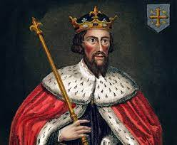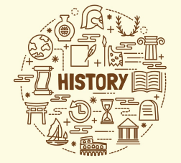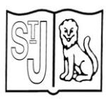

**Prior Learning**

* **Describe** the differences between primary and secondary historical evidence
* **Identify, describe and suggest reasons** for the use of a range of smaller artefacts excavated by archaeologists
* **Describe** one piece of personal secondary historical evidence and **explain** some of the ways in which it tells us about the lives of people at some point in the past.

**Key Knowledge** This investigation assists pupils to distinguish historical facts from myth, folklore and legend in relation to the people commonly referred to today as ‘the Vikings’, but who never shared or would have recognised that collective identity. They were loosely associated tribes of Norsemen from areas of modern-day Norway, Sweden and Denmark. One of their impacts on Britain was the terror that raiding parties brought to northern and eastern England for decades, as some Norsemen embarked on voyages of adventure in the summer months each year. Pupils are able to identify and reflect on the reasons why Viking Norsemen came to Britain and the impact they had. They are also encouraged to look beyond the terrifying activities of the Viking Norsemen to the motives of most Scandinavians who wished to travel to Britain during Anglo-Saxon times. For most, the two ‘treasures’ of England were large areas of flat fertile land and a temperate climate that provided a growing season of at least eight months. These were the settlers who massively outnumbered the raiders. Probably the most iconic and powerful instrument of Viking Norsemen strength was their brilliantly designed longship, which surpassed Anglo-Saxon vessels in every degree. Pupils are assisted to understand what it was about the longship that provided Viking Norsemen with such a commanding advantage when raiding English religious communities as well as when in direct combat with Anglo-Saxon military forces. No enquiry focusing on Viking Norsemen would be complete without considering why it is that horned helmets are popularly associated with Vikings. Through examining the issue of the horned helmet, as part of the investigation pupils are able to appreciate the difference between what is evidenced fact in the study of history and what is frequently myth, folklore or legend. The investigation ends with a detailed evaluation of the life and achievements of King Alfred the Great – the only English monarch to be granted the epithet ‘Great’. Pupils are able to reach a judgment as to whether he deserves this accolade through an examination of both primary and secondary historical sources.

**Key Vocabulary**

Vikings; Norsemen; Men of the North; tribe; race; chieftain; separate; Scandinavia; Norway; Sweden; Denmark; culture; unattached; invasion; homeland; adventure, Lindisfarne; Holy Island; chalice; monk; slave; priory; battle of Hastings; William; Duke of Normandy; Normans; Edward the Confessor; Normandy; English Channel; legacy.

**Subject Specific Skills**

**Describe the reasons** for the attack on the Holy Island of Lindisfarne in 793 by people referred to today as ‘the Vikings’;

**Describe** why ‘Vikings’ is not, in fact, the correct name or these people and **explain** who the attackers really were;

**Empathise** with the likely feelings of the people of the Kingdom of Northumbria and the **judgments** they might have made as news of the attack spread;

**Identify and describe** the design features of a longship and **explain** why it was an ideal vessel for Viking raiding parties along the coast of Britain;

**Interpret** a range of source evidence to **explain** why most Viking Norsemen travelled to Britain in Anglo-Saxon times and **justify their judgment**;

**Identify** and **describe** the distribution of those areas of Britain settled by Viking Norsemen;

**Compare and contrast** the homes of Viking Norsemen with those of Anglo-Saxons and **suggest reasons** for the similarities and differences **observed**;

**Explain** the difference between historical evidence and a myth, folklore and a legend, with reference to both the commonly held belief that Viking Norsemen wore helmets with horns and that the outlaw Robin Hood really existed;

**Evaluate** evidence relating to the achievements of Anglo-Saxon King Alfred the Great, **reach a judgment** as to whether he is justifiably ‘great’ and **justify their decision**;

**Describe** and **explain** why William, Duke of Normandy, fought the Anglo-Saxon King Harold for the English crown at Hastings on 14 October 1066.

**Year 4 History**

**Knowledge Organiser**

**Vikings**

**Key Individual**

King Alfred the Great

Alfred is the only monarch of England to be called ‘the Great’, but why? What did he achieve in his reign from 871 to 899 that was so special that he is remembered in this way?